Smart City Project Logical and Physical Diagrams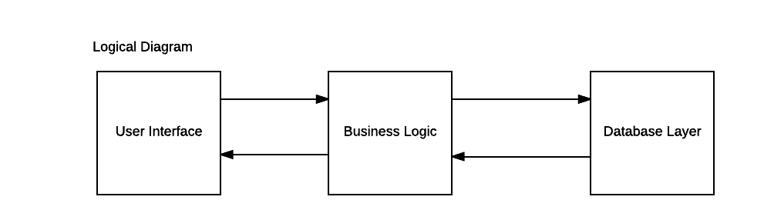

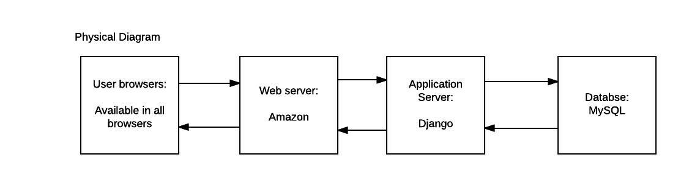

A three-tier architecture has been chosen because it can hold the three products separately. A two-tier architecture would not divide the user interface and business logic. The three-tier system will be more easily manageable as it allows the developer to update one of the tiers without affecting the others. It will also allow our team to work on their preferred areas: The developer with a html background will work on the user interface, the developer with a python background will work on the business logic and the developer with a database background will work on the database layer.